Hey,
We would like to request a feature that for the WMS app that has similar functionality to the auto pick function from the website.
A client is requesting this because currently items within the warehouse are scanned at random due to the WMS app not providing any batch information on which products should be picked. This is currently working within the website by using the auto pick but would be highly beneficial if it also displays it within the WMS like it does with the Pick From Location.

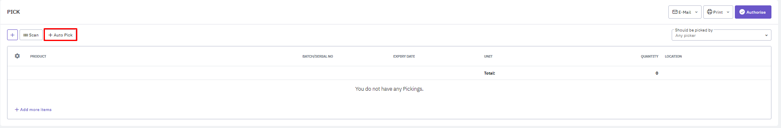

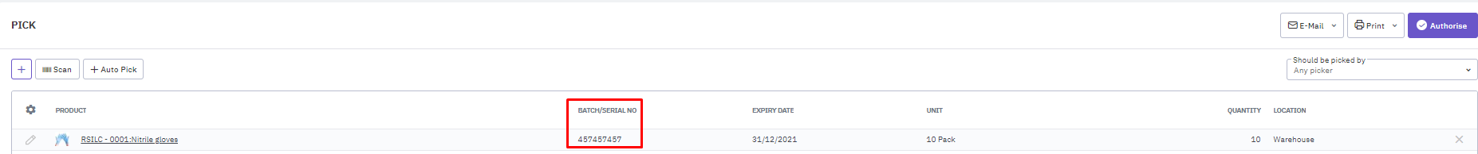

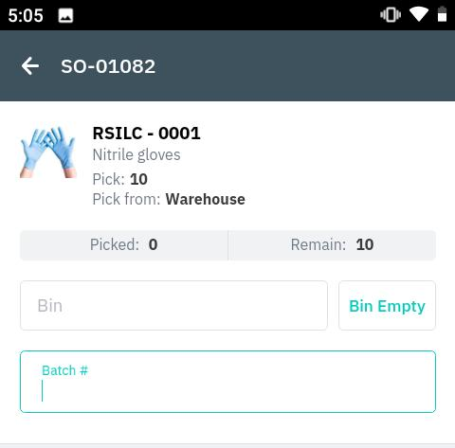
Best regards Sean.

